Machine Learning Project Documentation

Model Refinement
Project: This Was Not For Me — Detecting Gift Purchases as a Distinct Class of Noise in E-Commerce Recommender Systems
Team: AI in Marketing Capstone, Group 2 — [Team Member 1] / [Team Member 2] / [Team Member 3]
Repository: github.com/edasaruhan/SIC_AI_17_Capstone_Group_2 · Date: 19 September 2026
Every number in this document comes from the project's result files in repo/reports/results/ (JSON) and is traceable to a dated entry in repo/docs/DECISIONS.md. Figures are in repo/reports/figures/; the full results report is repo/docs/SONUCLAR.md.

1. Overview
The project tests whether gift purchases — interactions that say nothing about the buyer's own taste — contaminate e-commerce recommender systems. Two kinds of model are involved. The gift detector labels each Amazon review as self, gift_given, household, received or unclear. It went through three generations: a keyword proxy, an LLM annotator (Qwen3-4B-Instruct-2507 with a structured prompt), and a distilled ModernBERT-base classifier that labelled the entire experiment corpus of 4,598,612 reviews. The recommenders (SASRec and BPR in RecBole 1.2.0) are the measurement instrument: they are trained on six versions of the training data and compared on one identical test set.
Refinement therefore meant two different things. For the detector it meant raising label quality and throughput step by step, with every step measured against a reference fixed in advance. For the recommenders it meant making the experimental protocol correct and fair — not maximising accuracy — because the research question is whether accuracy is sensitive to gift interactions. Tuning each training-data condition separately would have turned that comparison into a comparison of tuning effort.
Three rules governed the phase: (1) every threshold was written into configs/base.yaml and docs/DECISIONS.md before the result it judges existed; (2) the 500 human-labelled validation reviews and the recommender test set were never used for tuning; (3) nothing was changed after a result was seen — problems found late are reported as limitations.
Table 1. Refinement at a glance
Component | Starting point | Refined version | Evidence
Gift detector | Keyword proxy — gift F1 0.46 against the human reference | LLM with prompt v3 and product title — gift (C1) F1 0.72, population-weighted | validation_500.json
Prompt and label schema | v1, four classes | v3, five classes (received added), explicit evidence rules | DECISIONS 26–27 Aug
Corpus-scale labeller | LLM: 3.6 reviews/s on 2 GPUs (≈15 days for 4.6M reviews) | ModernBERT-base student: 330–364 reviews/s per GPU (≈2 h per category) | distill_report_base.json, inference_*.json
Recommender protocol | RecBole defaults | Last-50 sequence window, C0 purchase mask, shadow-item mask, per-user outputs, isolated checkpoints | DECISIONS 14–16 Sep

2. Model Evaluation
2.1 Baseline: keyword proxy
The first detector was a regular-expression proxy built during exploratory analysis (phrases such as “gift”, “for my grandson”, “stocking stuffer”). It was never meant to be the final detector; it is the free baseline any learned model must beat.
Table 2. Keyword proxy, gift class
Reference labels | Precision | Recall | F1
200-review prompt-development set (author-assisted, not independent) | 0.610 | 0.762 | 0.678
LLM labels, Toys main frame (n = 10,000) | 0.645 | 0.313 | —
Independent human labels, 500 reviews | 0.412 | 0.512 | 0.457

Against the independent human reference the proxy is weak, and its misses are structural: 43.6% of the LLM's gift_given labels in Toys were grandchild purchases phrased without any gift word (“great game for my grandson”).
2.2 First LLM detector and Gate 1
Qwen3-4B-Instruct-2507 ran on Kaggle (2 × Tesla T4, vLLM, float16, JSON-schema-guided decoding) over a stratified sample of 47,200 reviews (4 categories × 11,800). Before the full annotation, four pass/fail criteria (Gate 1) were fixed in the configuration. All four categories passed 4/4. Toys and Games:
Table 3. Gate 1, Toys and Games (thresholds fixed 28 Aug 2026, before the run)
Criterion (failure it catches) | Threshold | Measured
Seasonality: Dec+Jan ÷ Jun–Sep gift rate, 95% CI above 1 (no signal) | ≥ 1.25 | 1.58 [1.43, 1.73]
gift_given among reviews the proxy did not flag (keyword imitation) | ≥ 1% | 18.0%
Parse failures / evidence-span downgrades (schema collapse) | < 1% / < 10% | 0.03% / 2.77%
Agreement with the 200-review development set (over-triggering; smoke test only) | ≥ 70% | 83.5%

Gate 1 also exposed what to improve: 14 of the 33 development-set disagreements went one way — human household, LLM gift_given (gift precision 0.80, household recall 0.64); the model's self-reported confidence carried no information (low coincided with unclear in 870 of 870 rows); and the keyword pattern used to find reviewers who received a gift had only 11% precision.
2.3 Independent human validation (500 reviews)
The decisive evaluation is a 500-review set labelled blind by a human annotator, who saw neither the LLM's nor the proxy's output. Only one of the three planned annotators completed the set, so inter-annotator agreement could not be measured and the Week-4 gate is recorded as INCOMPLETE — neither passed nor failed. The measurement methods were registered before the comparison. Because the set is stratified by the LLM's label, results are given both unweighted and re-weighted to the population.
Table 4. LLM annotator against the human reference
LLM vs human | Sample (500) | Population-weighted [95% CI]
Accuracy, five classes | 0.64 | 0.73 [0.66, 0.79]
Macro-F1, five classes | 0.54 | 0.49 [0.44, 0.56]
C1 axis (gift_given vs rest): precision / recall / F1 | 0.68 / 0.79 / 0.73 | 0.65 / 0.80 / 0.72 [0.62, 0.80]
C1b axis (gift_given + household + received): precision / recall / F1 | 0.85 / 0.93 / 0.89 | 0.84 / 0.74 / 0.79 [0.72, 0.85]

Per-class F1 on the sample: household 0.76, gift_given 0.73, self 0.58, unclear 0.36, received 0.28 (only 11 human labels). The two largest confusions were human household → LLM gift_given (33 reviews) and human self → LLM unclear (32). All 131 reviews the annotator marked as bought for the reviewer's own child were household to the human; the LLM agreed on 102 and called 19 a gift. Figures F17 (monthly LLM vs proxy rate), F18 (per-class F1) and F19 (prevalence by category) show these results.
Areas identified for improvement. (1) The binary gift label (C1) has population precision 0.65: roughly one in three LLM “gifts” is not a gift by the human standard, mostly purchases for the reviewer's own child. (2) received and unclear are unreliable. (3) The raw LLM prevalence in Toys (23.3%) overstates the human-calibrated one (19.0% [15.8, 22.3]). (4) The LLM is far too slow for the 4.6 million-review experiment corpus.
A threshold that was not applied. The Technology Review proposed a five-class macro-F1 ≥ 0.75 gate with an escalation path to Qwen3-8B. That threshold was never written into the configuration, and the Week-4 pre-registration (made before the labels were compared) defined F1 as a measurement, not a gate. The measured macro-F1 (0.54 / 0.49) would not have met 0.75, and the escalation was not carried out. The experiment uses the two binary axes, which are measured considerably better (F1 0.72–0.79) than the five-class average, which the two rare, ambiguous classes pull down.

3. Refinement Techniques
3.1 Prompt and schema engineering on a separate development set
- Prompt v2, from error analysis of 200 development reviews: separate realised gifts from merely proposed ones (evidence of use → self, no evidence → unclear); treat a recipient's reaction as evidence on its own; do not require a purchase verb (“was a great gift for our grandson”).
- Schema v3: received became a fifth class instead of being folded into self — information is not destroyed at annotation time; recipient became a closed string list with no null; the none / unknown rule for occasion moved into the prompt.
- Product context: product metadata was joined on parent_asin, so the prompt shows the product title (before, the model could not tell what “she loved it” referred to). The prompt forbids inferring a gift from the product type.
- Evidence verification: each label needs a verbatim evidence_span; if the span does not occur in the review, the row is downgraded to unclear and counted (2.77% of Toys rows, all to unclear).
- Earlier prompt versions were kept, so every label is traceable to the prompt that produced it, and the 200 development reviews were excluded from every evaluation set.
3.2 Trying different algorithms
- Annotator model. The choice followed the hardware actually available: every reachable GPU is pre-Ampere (Turing), with no bfloat16 and no FlashAttention. The hybrid-attention Qwen3.5 family was rejected for lack of a working Turing backend; Qwen3-4B-Instruct-2507 (dense, text-only, grouped-query attention, non-thinking) was selected.
- Knowledge distillation. The LLM's labels (46,655 after excluding the 500 human-validation reviews and 45 parse failures) were used to fine-tune ModernBERT-base (149M parameters) as a student. The student sees exactly the teacher's four input fields. A three-criterion fidelity gate was fixed before training. DeBERTa-v3-base was registered as a fallback to be tried once, only if ModernBERT failed; ModernBERT passed, so the fallback was never trained. Training both and keeping the better one would have been model selection on the gate's own data.
- Two recommender families. SASRec (self-attentive sequential model, primary) and BPR (matrix factorisation with a pairwise ranking loss) are both run — as a robustness check, not as competitors.
- Intervention variants. Removing gifts (C1); removing the broader “recipient did not choose it” set (C1b); keeping gifts under a separate shadow item ID (C3); each against a placebo that removes the same number of random rows (C4, C4b). Loss re-weighting (C2) was dropped: the first implementation added a weight column that RecBole never read, so “C2” would silently have been C0. It now raises an explicit error.
- Not done: no ensembles; the planned second annotator model (Gemma 4 E4B) and a TF-IDF + logistic-regression baseline for the student were listed in the plan but not run.
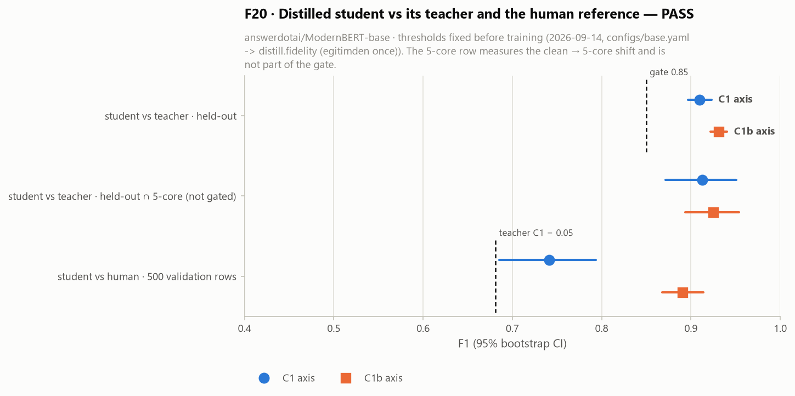
Figure 1 (F20). Distilled student against its teacher (held-out 10%) and against the human reference; dashed lines are the thresholds fixed before training.
3.3 Correctness refinements to the recommender protocol
Smoke tests on synthetic data and a local pre-flight on real data found protocol problems before any reported run. Each fix is locked by a test.
Table 5. Protocol fixes found before the reported runs
Problem found | Refinement
RecBole truncates long sequences to the first N items | Sequences are pre-built and the last 50 items are kept
SASRec's cross-entropy loss crashes with RecBole's default negative sampling | Negative sampling switched off for cross-entropy models
RecBole masks already-bought items using the condition's own training data, so items a condition removed re-entered the top-K list | Mask built from C0's training history in every condition (BPR)
C3 shadow items could be recommended | Shadow items scored −∞ at evaluation; none found in any top-K list
Parallel runs could overwrite each other's checkpoint (second-resolution file names) | One checkpoint directory per run
Kaggle's protobuf version broke RecBole's TensorBoard import | No-op writer substituted; metrics unaffected; status written to every report
RecBole reports only averages | Per-user metrics and top-20 lists captured from RecBole's own scores; must match its average within 5 × 10⁻⁷

3.4 Refining the interpretation, not the thresholds
C1's measured precision (0.65) means removal effects are diluted toward the placebo. Instead of changing labels or thresholds after seeing this, two decisions were recorded before any experiment ran: a reading rule (C1 ≈ C4 means “not detectable at this label precision”, never “no effect”; C1 > C4 is a lower bound on the true effect), and promoting the better-measured C1b/C4b axis from optional to core.

4. Hyperparameter Tuning
Hyperparameter tuning was deliberately minimal — a design choice, not an omission. (a) Tuning each training-data condition separately would confound the comparison: a gap between C1 and C4 could then come from tuning rather than from gifts. (b) The only independent detector reference (500 human labels) would be used up if prompts or thresholds were tuned on it. (c) The test set is used once.
Table 6. Settings used (none tuned on validation or test data)
Model | Setting | Value | How chosen
LLM annotator | Decoding | temperature 0.0; ≤ 220 new tokens; JSON-schema-guided; one retry on parse failure | Fixed before the run
LLM annotator | Serving | float16; context 4,096 tokens; prefix caching; 2 GPUs data-parallel | Measured prompt length (2,277 tokens) and hardware
ModernBERT student | Training | 3 epochs; batch 32; learning rate 3 × 10⁻⁵; warm-up 0.1; weight decay 0.01; ≤ 1,024 tokens; fp16; gradient checkpointing | Common fine-tuning defaults; no search; no checkpoint selection
SASRec, BPR | Training | RecBole 1.2.0 defaults; ≤ 300 epochs; early stopping on validation NDCG@10; last 50 items | Identical for all conditions and seeds
All | Seeds | 42 (single runs); 42, 1337, 2024 (experiment) | Fixed in configuration

What was adjusted, and what it taught us. The settings that did change affect speed or memory, not results, and each change was checked to leave outputs unchanged:
- Prefix caching is mandatory: the system prompt is 2,277 tokens and a median review about 30, so about 99% of every prefill is shared. Without caching, roughly 116 million redundant prefill tokens would have been computed.
- Measure, don't assume. The Technology Review estimated 1,000–2,000 output tokens/s; the T4 delivered 159. Engine start-up (196 s) is now reported apart from generation — mixing them made a 200-review smoke test look 4.6 times slower than production.
- Student inference batches by a token budget (≤ 65,536 tokens) instead of a fixed row count; one-shot and batched predictions differ by at most 1.2 × 10⁻⁷ in probability.
- Gradient checkpointing was switched on because ModernBERT's padding removal needs FlashAttention, which the T4 lacks. It does not change results; its cost is extra training time (commonly around 30%; not measured separately here).
- Evaluation batch size is capped by the number of user × item scores (2²⁶ ≈ 67 million), because RecBole's default collapsed to one user per batch once the catalogue exceeded 4,096 items.
Impact. The student trained in 28 minutes on one T4 (final training loss 0.276) and labelled 4.6 million reviews in 3.7 GPU-hours; the 72 recommender runs took 83 GPU-hours across eight Kaggle sessions. Limitation: without a hyperparameter search, absolute recommender accuracy is probably not optimal, and because RecBole's per-epoch logs were not captured we cannot say whether any run reached the 300-epoch cap. Every condition used the same protocol, so the comparisons are unaffected.

5. Cross-Validation
K-fold cross-validation was not used; each model has a scheme suited to its data.
Recommenders: temporal leave-one-out
For each user, the chronologically last interaction is the test item and the second-to-last the validation item (equal timestamps are broken by a stable row ID). Random or k-fold splits would put a user's future purchases into training and inflate every metric. Two rules were added for this study: the test item must be the user's own (self) purchase, and the split and the user/item universe are frozen on C0, so all six conditions are scored on identical test pairs — a SHA-256 hash of the test pairs was identical in all 72 runs. Evaluable users: Toys 117,386 of 268,652 (43.7%), Grocery 238,756 of 268,991 (88.8%).
Changes made during refinement: (1) stable tie-breaking for identical timestamps; (2) for SASRec, a validation user whose entire training history a condition removes is dropped from the early-stopping set only — counted in every report (Toys C1b: 45,981 users) — while the test set never changes; (3) the already-bought mask is C0's in every condition.
Seeds and bootstrap instead of folds. Each cell ran with three seeds, and every comparison uses a paired bootstrap over users on seed-averaged per-user metrics (1,000 resamples; 2,000 for Gate 2). The seed coefficient of variation of C0 Recall@10 was 0.002–0.025 (threshold 0.10). Seven cells that ran twice in different Kaggle sessions — three of them under different code revisions — produced bit-identical outputs.
Detector: disjoint held-out sets
The student used a stratified 90/10 split (category × label, seeded with a stable CRC32 hash): 41,988 training and 4,667 held-out reviews. The 500 human-validation reviews were excluded by their (category, row ID) pair; the overlap was independently counted as zero, including by exact text. The 546 held-out reviews that also fall in the 5-core experiment corpus give a separate distribution-shift check: C1 F1 0.913 there against 0.910 overall — no shift detected, although the interval is wide.

6. Feature Selection
Features were selected by design; no ablation study was run. The decisions and their measured consequences:
- Detector inputs — four fields: dataset category, product title, review title and review text (cut at 6,000 characters). The product title was added in prompt v3 after error analysis showed the model could not resolve what a review referred to. Rating, helpfulness votes, images and the rest of the metadata were left out. The product type is context, not evidence.
- Student inputs equal the teacher's (same fields, same truncation) — a precondition for measuring fidelity; training and inference text for the same review were identical in 300 of 300 sampled rows. The 1,024-token cap is ample: the evidence sits at a median 1–3% into the review body, and even a 512-token limit would have lost it in only 0.013–0.044% of gift reviews.
- Output fields: the LLM's confidence field was dropped from the analysis because it duplicated unclear (870 of 870).
- Recommender features: IDs only (user, item, timestamp). SASRec and BPR are ID-based, and side features would have added a second difference between conditions. Product sub-categories (metadata categories[1]) are used only by the marketing metrics.
- Sequence window: SASRec sees the most recent 50 items.

Test Submission

1. Overview
Here the “test submission” is the one-time evaluation of the frozen pipeline on data it was never tuned on, in three layers: the LLM detector against the independent human set, the distilled student against its held-out set and the human set, and the recommender experiment on the temporal test split. The steps were:
- Freeze the detector (prompt v3, Qwen3-4B) and label 47,200 sampled reviews on Kaggle; pass Gate 1.
- Compare with the 500 blind human labels, with measurement methods registered first.
- Train the student with fixed thresholds; pass the fidelity gate (3/3); label all 4,598,612 reviews of the two experiment corpora.
- Build RecBole input files from the student labels, freeze split and universe on C0, write the six condition files.
- Run the 72-run matrix ({Toys, Grocery} × {SASRec, BPR} × six conditions × three seeds) in eight Kaggle sessions, two GPUs in parallel, with a time guard for the 12-hour session limit.
- Audit every downloaded output locally, then compute Gate 2, the paired-bootstrap contrasts and the marketing metrics.

2. Data Preparation for Testing
Detector test data
- 500 reviews drawn from the 47,200 annotated ones, stratified by the LLM's label so that rare classes appear; the proportional main frame is kept apart from the keyword-boosted frames so population estimates can be re-weighted.
- Disjoint from the 200 prompt-development reviews. The exclusion key is the (category, row ID) pair: row IDs restart in each category, so a plain ID list would have excluded unrelated reviews.
- Blind: the labelling sheet contains neither the LLM's answer nor the proxy flag. Free-text notes were normalised on ingest, keeping the raw note.
Recommender test data
- Preprocessing: verified purchases, minimum word count, de-duplication (earliest review kept), then iterative 5-core filtering — once, on C0.
- Temporal leave-one-out with the self-only test rule; users whose whole sequence is gifts stay in the universe but are not evaluated.
- Conditions change training rows only; validation and test rows are never altered, so test pairs are identical across conditions (verified by hash).
- Leakage tests: a test item never appears in training; shadow IDs never appear in validation or test; test items are self-labelled.
- Considerations: review dates lag purchase dates (the seasonal peak appears in December–January), and only purchases that were reviewed are visible.

3. Model Application
The student was applied in chunks of 200,000 reviews, each written to disk when it finishes, so an interrupted Kaggle session resumes where it stopped; the final file must hold exactly one label per 5-core review. Inference refuses to start unless the student's fidelity report says PASS.
Applying the distilled student to the full corpus
# detection/inference.py - condensed; comments and variable names translated
for i, start in enumerate(range(0, n, chunk_rows)): # chunk_rows = 200,000
part = parts / f"part_{i:05d}.parquet"
if part.exists() and not force:
continue # resume: finished chunks are never recomputed
chunk = inputs.slice(start, chunk_rows).select("row_id", "text").collect()
probs = student.predict_proba(chunk["text"].to_list()) # fp16, token-budget batches
pl.DataFrame({
"row_id": chunk["row_id"],
"purchase_type": [LABELS[j] for j in probs.argmax(axis=1)],
**{f"p_{lab}": pl.Series(probs[:, k], dtype=pl.Float32)
for k, lab in enumerate(LABELS)},
}).write_parquet(part)
labels = pl.concat([pl.read_parquet(p) for p in sorted(parts.glob("part_*.parquet"))])
if labels.height != n or labels["row_id"].n_unique() != n:
raise RuntimeError("the experiment expects EXACTLY one label per 5-core review")

Each recommender run trains RecBole on one condition file and evaluates the frozen test set: python -m gift_contamination.recsys.run_experiment --category high --condition C1 --model SASRec --seed 42. The runner masks shadow items and C0-bought items, captures per-user metrics and top-20 lists, and stops if they disagree with RecBole's own average. The 72 runs were launched by scripts/kaggle_experiment.py, which skips a run only if both its report and its per-user file exist, and does not start a run that would not finish before the session limit. Throughput: the student labelled 364 reviews/s (Toys) and 330 reviews/s (Grocery) per T4; a SASRec run took 23–194 minutes and a BPR run 12–48 minutes.

4. Test Metrics
Recommender metrics: Recall@10 (primary, fixed before the runs), NDCG@10 and HR@10 (equal to Recall@10 because each user has one test item), also at 20. Detector metrics: precision, recall and F1 per class and on the two binary axes, with bootstrap intervals.
Table 7. Detector: training, held-out and human test metrics
Distilled student (ModernBERT-base) | Value
Final training loss (3 epochs) | 0.276
Held-out vs teacher, C1 axis F1 [95% CI] (gate ≥ 0.85) | 0.910 [0.897, 0.923]
Held-out vs teacher, C1b axis F1 (gate ≥ 0.85) | 0.931 [0.922, 0.941]
Held-out vs teacher, five-class accuracy / macro-F1 | 0.887 / 0.743
Human set, C1 axis F1 (teacher 0.731; gate: drop ≤ 0.05) | 0.742 [0.685, 0.793]
Human set, C1 axis precision / recall | 0.661 / 0.845

The student reproduces its teacher closely and is as good as the teacher against the human (0.742 vs 0.731) — but it also inherits the teacher's bias: it does not correct the “own child counted as a gift” error.
Table 8. Recommenders: validation vs test
C0, Recall@10 (mean of three seeds) | Validation | Test | Test vs validation
Toys · SASRec | 4.73% | 4.31% | −9%
Toys · BPR | 1.85% | 1.62% | −12%
Grocery · SASRec | 3.53% | 3.01% | −15%
Grocery · BPR | 1.70% | 1.45% | −15%

Test values sit 9–15% below validation, consistently across models and categories — no cell behaves differently. Two reasons are expected and we cannot separate them: the validation set is the one early stopping optimised, and the two sets are different populations (validation covers every user and any kind of next purchase, the test only users whose last purchase is their own). RecBole's per-epoch training loss was not captured.
Final results. Gate 2 — four setup-validity criteria fixed before the runs (identical test pairs, universe ⊆ C0, placebo not better than C0, seed stability) — passed in all four category × model cells.
Table 9. Test results (pp = percentage points of Recall@10; n.s. = 95% CI includes 0)
Cell | C0 Recall@10 | C1 − C4 (primary) [95% CI] | C1 − C0 | C3 − C1
Toys · SASRec | 4.31% | +0.55 pp [+0.48, +0.61] (+16%) | −0.31 pp (−7%) | −0.12 pp (−3%)
Toys · BPR | 1.62% | +0.48 pp [+0.44, +0.53] (+40%) | +0.07 pp (+4%) | −0.17 pp (−10%)
Grocery · SASRec | 3.01% | +0.04 pp [+0.005, +0.07] (+1%) | n.s. | −0.09 pp (−3%)
Grocery · BPR | 1.45% | +0.02 pp [−0.01, +0.05] (n.s.) | n.s. | n.s.

Removing gift interactions hurts far less than removing the same number of random interactions (C1 > C4): gift rows carry less information about the user's own next purchase than average rows. The effect is large in the high-gift category and small or undetectable in the low-gift control — the Toys − Grocery difference is positive in all four comparisons. Whether removal beats keeping everything depends on the model: +4% for BPR, −7% for SASRec in Toys. Tagging gifts with a shadow ID (C3) was never better than removal. For marketing: in Toys, a sequential model's extra recommendations toward a gift's sub-category halve after about one of the user's own purchases (≈2–4 weeks, approximate); in BPR the excess is diluted by new purchases rather than fading.
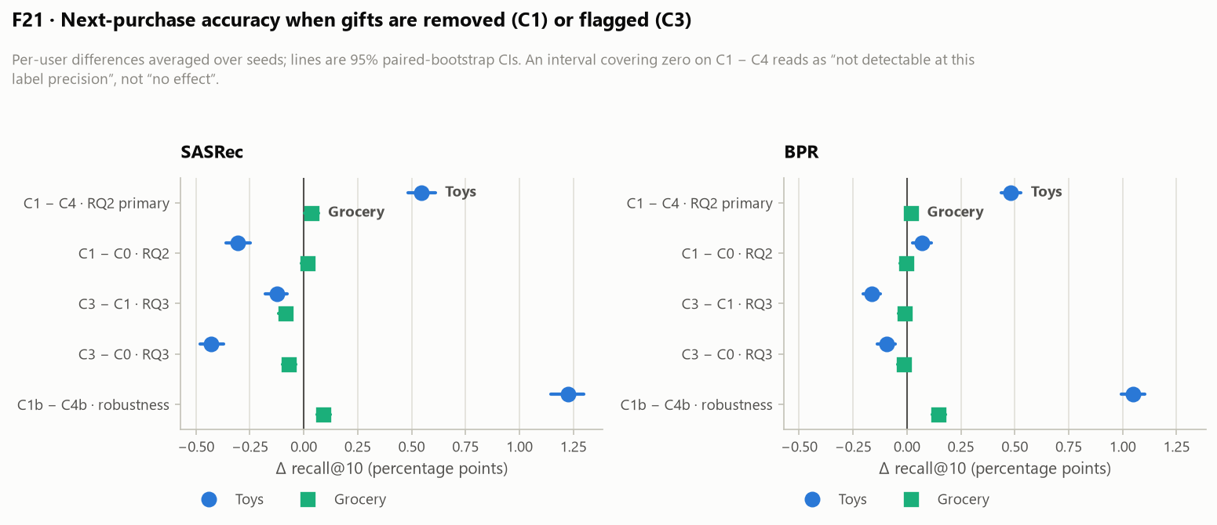
Figure 2 (F21). Condition contrasts on the test set, Recall@10, 95% paired-bootstrap intervals.
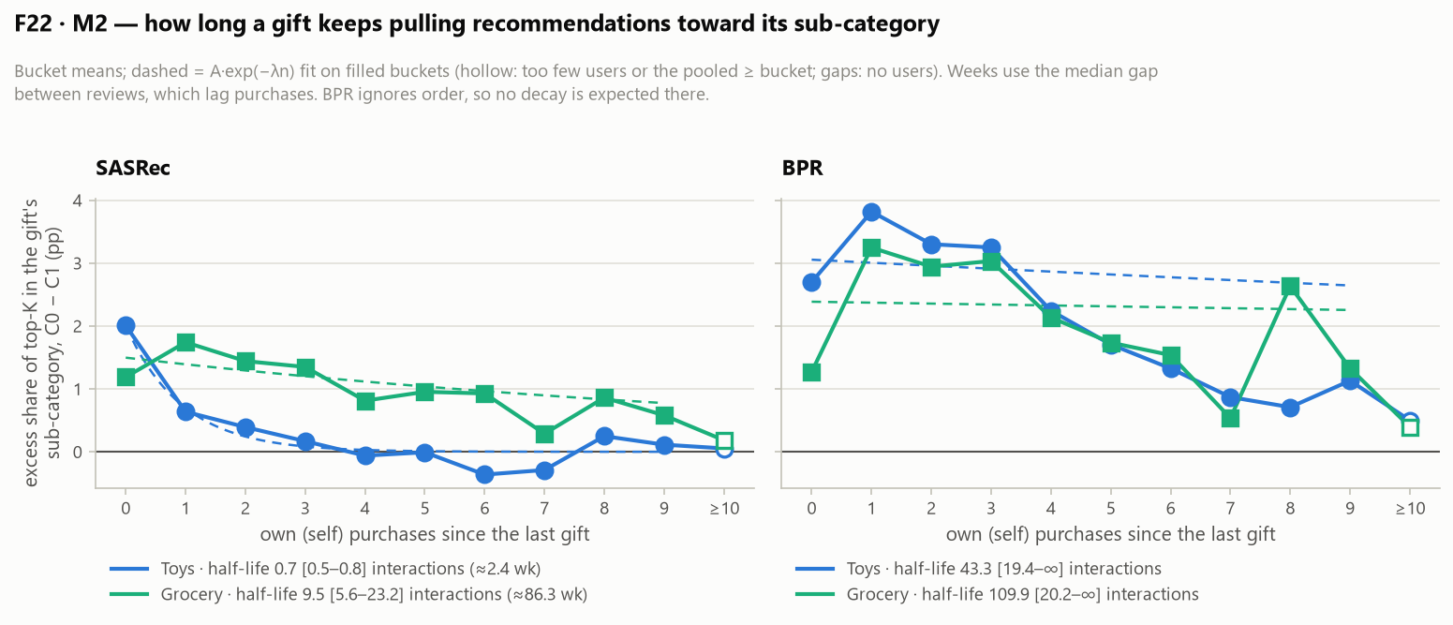
Figure 3 (F22). Contamination half-life: excess share of the gift's sub-category in the top-10 list by the number of the user's own purchases since the gift.

5. Model Deployment
The project is a research pipeline and was not deployed as a live service (see the separate Deployment submission). The detector was nevertheless used at production scale: the frozen student labelled every review in the experiment corpora as an offline batch job, and its label file is the artefact every downstream step consumes. For a retailer, the practical deployment is a pre-training filter — flag gift interactions when data is ingested and exclude or down-weight them before the recommender is retrained. The flag should only suppress interactions and must never be used to target people based on inferred household composition.

6. Code Implementation
Condensed from repo/src/gift_contamination/; Turkish comments and some variable names are translated. The full modules, with 389 tests, are in the repository.
Refinement — the student's fidelity gate
# detection/distill.py - fidelity gate (condensed; comments translated)
def fidelity_verdict(cfg, holdout_axes, human_axes):
"""Three criteria fixed BEFORE training. An unmeasurable criterion -> INCOMPLETE."""
fid = cfg.get("distill.fidelity")
c1 = holdout_axes["C1"]["f1"]["value"] # student vs teacher, held-out 10%
c1b = holdout_axes["C1b"]["f1"]["value"]
student = human_axes["C1"]["f1"]["value"] # student vs human, 500 reviews
teacher = teacher_c1_on_human(cfg) # teacher vs the same human labels
criteria = {
"1_c1_axis_vs_teacher": {"passed": c1 >= fid["c1_axis_f1_min"]}, # 0.85
"2_c1b_axis_vs_teacher": {"passed": c1b >= fid["c1b_axis_f1_min"]}, # 0.85
"3_c1_axis_vs_human_not_worse_than_teacher":
{"passed": student >= teacher - fid["max_drop_vs_teacher_on_human"]}, # 0.05
}
decisions = [c["passed"] for c in criteria.values()]
verdict = ("INCOMPLETE" if any(d is None for d in decisions)
else "PASS" if all(decisions) else "FAIL")
return {"criteria": criteria, "verdict": verdict}

Refinement — placebo and shadow-token conditions
# recsys/conditions.py - conditions touch TRAINING rows only (condensed)
def apply_condition(df, code, *, seed):
train = pl.col("split") == SPLIT_TRAIN
if code in PLACEBO_OF: # C4 -> C1, C4b -> C1b
# Remove exactly as many RANDOM training rows as the source condition removes.
# The count is derived in code, never typed in by hand.
n_remove = df.filter(train & gift_mask(PLACEBO_OF[code])).height
indexed = df.with_row_index("_row")
drop = indexed.filter(train)["_row"].sample(
n_remove, seed=_seed_for(seed, code), shuffle=True) # stable crc32 seed
out = indexed.join(drop.to_frame(), on="_row", how="anti").sort("_row").drop("_row")
elif code in SHADOW_LABELS: # C3: gifts move to a shadow item ID
shadow = train & pl.col("label").is_in(list(SHADOW_LABELS[code]))
out = df.with_columns(
pl.when(shadow).then(pl.col("item_id").cast(pl.String) + pl.lit("::gift"))
.otherwise(pl.col("item_id").cast(pl.String)).alias("item_id"))
else: # C1 / C1b: remove labelled rows
out = df.filter(~(train & gift_mask(code)))
return out

Test preparation — split and evaluation rule
# recsys/atomic.py - temporal leave-one-out and the self-only test rule
def assign_splits(df):
"""Per user in time order: last = test, second-to-last = valid, the rest = train.
Equal timestamps are ordered by row_id so the split is identical on every run."""
ordered = df.sort(["user_id", "timestamp", "row_id"])
n = pl.len().over("user_id")
pos = pl.int_range(pl.len()).over("user_id")
return ordered.with_columns(
pl.when(pos == n - 1).then(pl.lit(SPLIT_TEST))
.when(pos == n - 2).then(pl.lit(SPLIT_VALID))
.otherwise(pl.lit(SPLIT_TRAIN)).alias("split"))
def eval_eligible(df, label_col="purchase_type"):
"""Only users whose test item is their OWN purchase are evaluated."""
test = df.filter(pl.col("split") == SPLIT_TEST)
return test.filter(pl.col(label_col) == SELF)["user_id"]

Test evaluation — paired bootstrap and reading rule
# analysis/experiment_stats.py - paired bootstrap and the pre-registered reading
def paired_bootstrap(a, b, *, names, n_boot, ci, seed):
"""Same users under two conditions: mean of (a - b) with a percentile CI.
Users are resampled; every metric shares the same resample."""
boot = _boot_means(a - b, n_boot, np.random.default_rng(seed))
return {name: {"diff": float((a[:, j] - b[:, j]).mean()),
"ci": _ci(boot[:, j], ci)} for j, name in enumerate(names)}
def interpret_placebo(ci):
"""Reading rule fixed before any experiment (DECISIONS 2026-09-14)."""
lo, hi = ci
if lo > 0:
return "alt_sinir" # lower bound: the true effect is at least this large
if hi < 0:
return "negatif" # negative: reported as it is
return "saptanamadi" # not detectable - never written as "no effect"

Conclusion
Refinement took the gift detector from a keyword proxy (gift F1 0.46 against the human reference) to an LLM annotator (population C1 F1 0.72) and then to a distilled ModernBERT student that matches the LLM on held-out data (C1 F1 0.91; 0.74 against the human) while running about 180–200 times faster per GPU — which made labelling all 4.6 million experiment reviews feasible. On the recommender side, refinement consisted of protocol fixes that make the six conditions comparable; hyperparameters were deliberately not tuned.
Final performance. Gate 2 passed in all four cells. The primary contrast C1 − C4 is positive with a 95% interval above zero for both models in Toys (+16% SASRec, +40% BPR) and for SASRec in Grocery (+1%), and not detectable for BPR in Grocery; under the pre-registered rule these are lower bounds. The baseline (C0) reaches a test Recall@10 of 4.31% (SASRec) and 1.62% (BPR) in Toys, 3.01% and 1.45% in Grocery.
Challenges.
- Only one of three annotators delivered: label reliability could not be measured, and the Week-4 gate stays INCOMPLETE.
- Label noise — C1 precision 0.65, inherited unchanged by the student — dilutes every removal effect.
- Every available GPU is pre-Ampere (no bfloat16, no FlashAttention), which shaped model choice and memory settings.
- Kaggle's 12-hour sessions and weekly quota: the matrix was split across eight sessions with a time guard and resume logic; the first attempt crashed on a protobuf conflict and was fixed without affecting any metric.
- RecBole requires numpy 1.x and runs in a separate environment; its per-epoch logs were not captured, so epoch counts are unknown.
- Found after the results: a gift in the validation position (the last purchase before the test item) is not removed by any condition, and SASRec sees it in its test input — 15.6% of Toys test users. This shrinks SASRec's measured effects rather than inflating them. It is documented as a limitation; no definition or number was changed.

References
- Hou, Y., Li, J., He, Z., Yan, A., Chen, X., & McAuley, J. (2024). Bridging Language and Items for Retrieval and Recommendation. arXiv:2403.03952. Dataset: https://amazon-reviews-2023.github.io/
- Kang, W.-C., & McAuley, J. (2018). Self-Attentive Sequential Recommendation. ICDM 2018, 197–206.
- Rendle, S., Freudenthaler, C., Gantner, Z., & Schmidt-Thieme, L. (2009). BPR: Bayesian Personalized Ranking from Implicit Feedback. UAI 2009, 452–461.
- Zhao, W. X., et al. (2021). RecBole: Towards a Unified, Comprehensive and Efficient Framework for Recommendation Algorithms. CIKM 2021. arXiv:2011.01731. https://recbole.io/
- Warner, B., et al. (2025). Smarter, Better, Faster, Longer: A Modern Bidirectional Encoder for Fast, Memory Efficient, and Long Context Finetuning and Inference (ModernBERT). ACL 2025. arXiv:2412.13663
- Qwen Team (2025). Qwen3 Technical Report. arXiv:2505.09388. Model: https://huggingface.co/Qwen/Qwen3-4B-Instruct-2507
- Kwon, W., et al. (2023). Efficient Memory Management for Large Language Model Serving with PagedAttention (vLLM). SOSP '23.
- Hinton, G., Vinyals, O., & Dean, J. (2015). Distilling the Knowledge in a Neural Network. arXiv:1503.02531
- He, P., Gao, J., & Chen, W. (2023). DeBERTaV3: Improving DeBERTa using ELECTRA-Style Pre-Training with Gradient-Disentangled Embedding Sharing. ICLR 2023. arXiv:2111.09543
- Knowledge Distillation in Automated Annotation: Supervised Text Classification with LLM-Generated Training Labels. (2024). arXiv:2406.17633
- Pangakis, N., Wolken, S., & Fasching, N. (2023). Automated Annotation with Generative AI Requires Validation. arXiv preprint.
- Wang, W., Feng, F., He, X., Nie, L., & Chua, T.-S. (2021). Denoising Implicit Feedback for Recommendation. WSDM '21, 373–381.
- Krichene, W., & Rendle, S. (2020). On Sampled Metrics for Item Recommendation. KDD '20, 1748–1757.
- Ferrari Dacrema, M., Cremonesi, P., & Jannach, D. (2019). Are We Really Making Much Progress? RecSys '19, 101–109.
- Efron, B., & Tibshirani, R. J. (1993). An Introduction to the Bootstrap. Chapman & Hall.
- Wolf, T., et al. (2020). Transformers: State-of-the-Art Natural Language Processing. EMNLP 2020 (System Demonstrations).
- Software: polars, PyTorch, Hugging Face transformers, vLLM 0.28, RecBole 1.2.0, pydantic, matplotlib, pytest. Compute: Kaggle Notebooks (2 × NVIDIA Tesla T4).
AI Authorship Disclosure
This document was drafted with substantial assistance from a large language model (Claude, Anthropic); the project code was also developed with the same assistant under the team's direction. Every number was taken from the project's own result files produced by the team's code, and the text was checked against them. The team reviewed the content and takes responsibility for it. This disclosure follows the submission guideline that AI-generated documents be identified.

